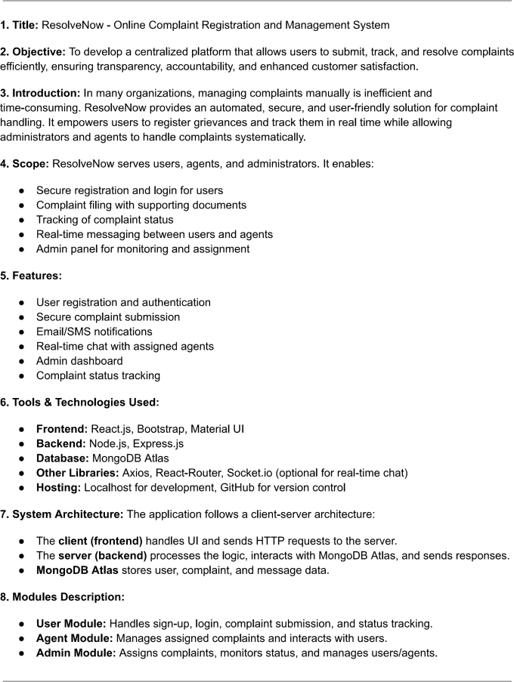

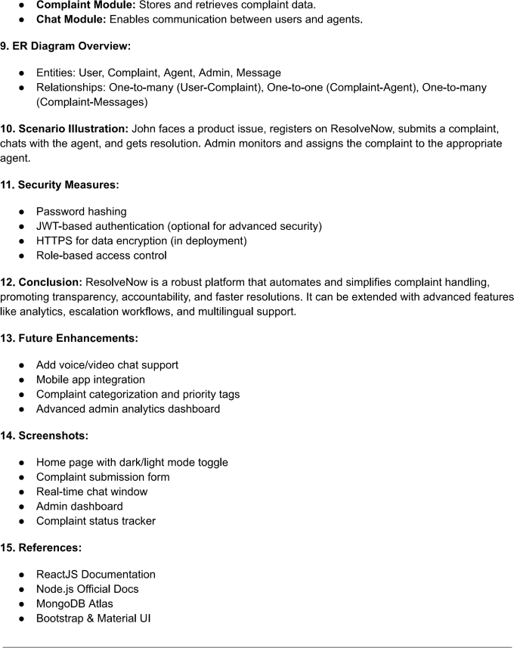

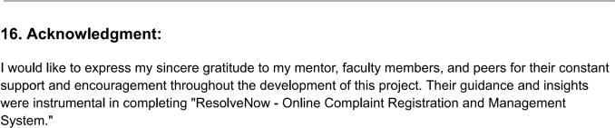

**17.Contact Information:**

**Developer:**Neelapala DivyaSree

**Email:** 23pa1a12e7@vishnu.edu.in

**Github link:** https://github.com/DIVYANEELAPALA1205/grocerystore.git

**Prepared by:** NeelapalaDivyasree

**Course&Department:** BTECH IT

**College:**VISHNU INSTITUTE OF TECHNOLOGU BHIMAVARAM

**Date:** 17-07-2025